Section A: Directory structure

As shown above, my directory is stored in a manner that makes it easy to navigate. My files are organised into folders of each type. I have also ensured that there is only one JavaScript and one CSS folder, to show that I understand the use of ID’s and classes to identify different elements to change. All my files are labelled clearly, to reduce confusion when viewing.

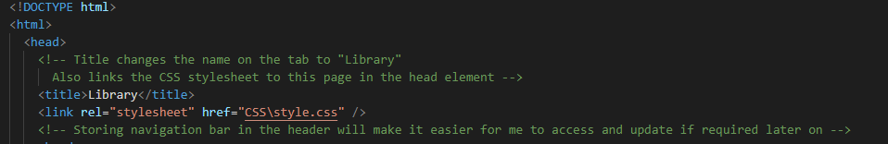

As shown above, my html files are linked to CSS using the <link> element. This allows me to have an external stylesheet for all files and shows my understanding of connecting them together.

For html files that utilise JavaScript (the pay and success screens), I have also linked these to an external file, which enables me to store all my methods in one file.

Section B: Frontend

Desktop view

Desktop view


Smartphone view

Section C: RESTful

Unfortunately, I was unable to get my credit card details to POST to the server. But I have made use of verification using JavaScript, which is shown below.

Error message for incorrect card details

Error message for incorrect card number length

Error message for incorrect month

Error message for incorrect security code

Section D: Usability and accessibility checklist

1. Alt text for images: allows users who may be visually impaired to understand what images are when viewing the page.
2. Universal navigation bar: each page has the same navigation bar, ensuring that users of my site will not become lost when viewing.
3. Animations on hover: Hovering over certain elements in my webpage will cause them to glow, which increases interactivity with my users and gives visual feedback.
4. Font and colour: Text on my page is consistently the same font and colour, which will clear any confusion or difficulties reading.
5. Images: Images make is much more accessible and usable for users, as it will give them an understanding of what they are viewing.